EXPERIMENT 9

**Aim :-** Design of 3D Mountains using Blender.

**Objective :-** To Design a 3D Mountains using features of Blender 2.8.

**Steps to be followed are –**

* Open blender and remove the cube and camera that’s already there.
* Add a plane and then go to edit mode and subdivide it.
* Add displace modifier to it.
* Assign the cloud texture.
* After doing the above step we will add an UV sphere and adjust it to the center of the plane and then we will open it in edit mode and select all the vertex and add them as a vertex group.
* We will get something like this -

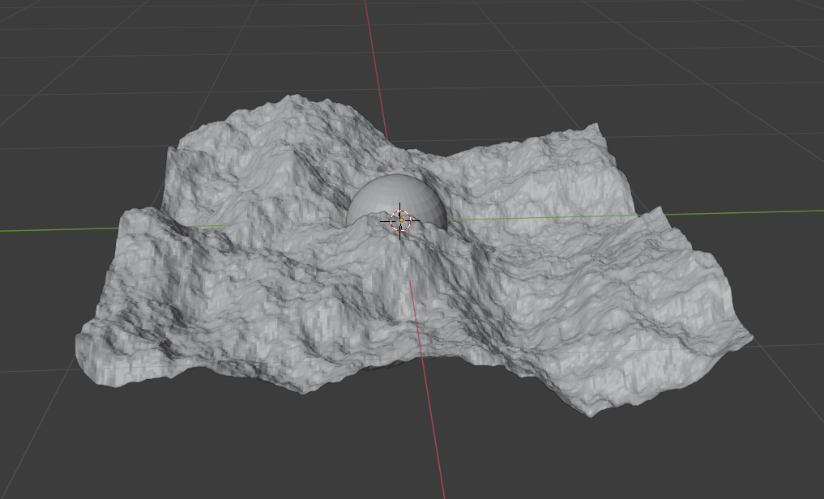

* After the above step we will add a vertex weight proximity modifier and then we will make a adjustments that if we move sphere then we will able to control the plane and then we will combine all the vertex of the sphere and make them one point so that one single point control the plane.
* After making certain adjustments, we will get the final output.

**OUTPUT –**

